Unit 7 Assignment 3

Quiz Instructions
Use the notes and textbook to answer the following questions.

Question 1 1 pts
This is a species which has been categorized as very likely to become extinct.
endangered species
native species
extinct species
invasive species

Question 2 1 pts
This is the place where organism live out their lives
biosphere
habitat
niche
ecosystem

Question 3 1 pts
This is how a species finds food and lives out its life.
habitat
ecosystem
niche
biosphere

Question 4 1 pts
This is the introduction of contaminants into the natural environment that cause adverse change
pollution
invasive species
native species
climate change

Question 5 1 pts
These are plants, animals, or pathogens that are non-native (or alien) to the ecosystem under consideration and whose introduction causes or is likely to cause harm.
endangered species
invasive species
native species
extinct species

Question 6 1 pts
A species that normally lives and thrives in a particular ecosystem.
native species
endangered species
extinct species
invasive species

Question 7 1 pts
This is a change in the statistical distribution of weather patterns when that change lasts for an extended period of time
ecological change
endangered species
climate change
invasive species

Question 8 1 pts
Panda bears have this status as there are relatively few in number and are likely to go extinct without any intervention
extinct species
endangered species
invasive species
native species

Question 9 1 pts
The forest is this for a mountain lion as it is where it lives out its life
ecosystem
biosphere
niche
habitat

Question 10 1 pts
Black bears and mountain lions can share the same habitat but they eat different foods. This means they have different
niches
biospheres
communities
ecosystems

Question 11 1 pts
-Exhaust fumes from vehicles.
-The burning of fossil fuels, such as coal, oil, or gas.
-Harmful off-gasing from things such as paint, plastic production, and so on.
-Radiation spills or nuclear accidents.
Each of these is a type of this:

trophic level
autotroph
pollution
niche

Question 12 1 pts
The brook trout is a fish which is not native to Idaho. The brook trout is faster and more aggressive than the native cutthroat throat which allows it outcompete it for food resources. The brook trout is an example of a
invasive species
endangered species
extinct species
native species

Question 13 1 pts
The cutthroat trout is a fish which evolved in the state of Idaho. This is an example of a:
endangered species
native species
extinct species
invasive species

Question 14 1 pts
The Mendenhall Glacier in Alaska has been reduced over the last 50 years. This is evidence of
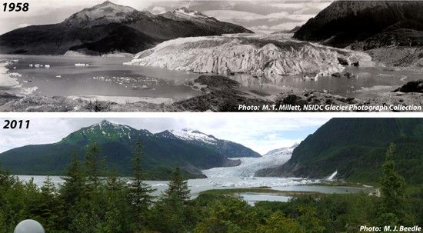
Desertification
Ecological succession
Climate Change
Habitat degradation

