Unit 1 Test free response examples:

Short Answer questions:

Example 1:

Cells are made up mostly of water.
In one or two sentences, explain why the specific heat of water is important to a cell.

Example 2:

The physical structure of a protein often reflects and affects its function.
Describe THREE types of chemical bonds/interactions found in proteins. For each type, describe its role in determining protein structure.

Example 3:

Proteins–large complex molecules–are major building blocks of all living organisms. Discuss the following in relation to proteins.
The chemical composition and levels of structure of proteins

Long Answer questions:

Example 1:

The stems and fruits of pineapple plants contain a group of protein-digesting enzymes collectively called bromelain and often used as an anti-browning agent for fruits and vegetables. Fruits and vegetables brown when they are bruised during transport or sliced and exposed to air. This browning is controlled by enzymatic pathways that produce brown pigments. The browning of fruits and vegetables reduces the nutritional value of the food, so anti-browning agents such as bromelain are used.

(a) Identify the type of monomer of which this enzyme is composed.
(b) Bromelain works by breaking the enzymes that cause browning into smaller molecules. Explain how the reaction that breaks up the enzymes occurs.
(c) The pH of a solution determines the charge of certain R groups. The pH of pineapple fruit ranges from 3.5 to 5.2. Predict the effect on the activity of bromelain if it is used in a product with a pH of 11.
(d) Provide reasoning to justify your prediction.

Example 2:

- The diagram shows water molecules as solid ice at 0°C and as a liquid at 25°C.

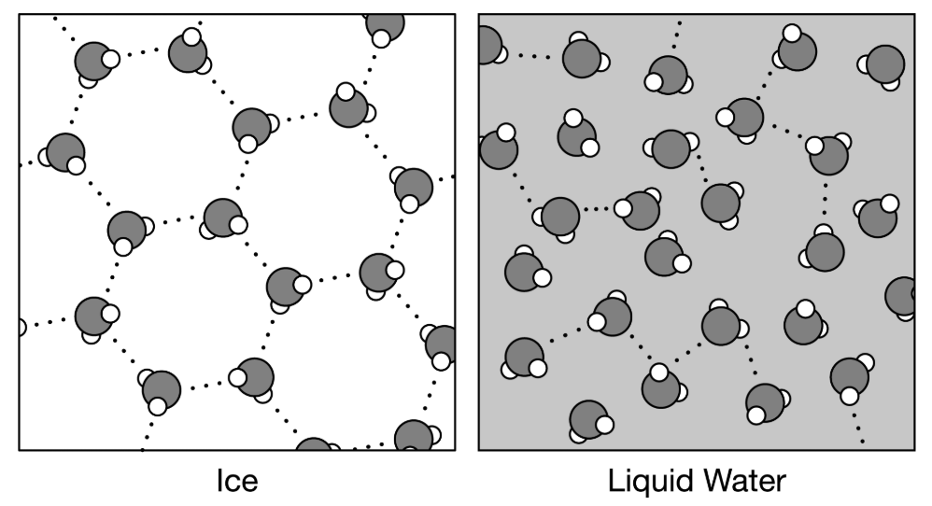

(a) Describe why hydrogen bonds form between water molecules.
(b) Explain why the arrangement of water molecules is different in ice and water.
(c) To help explain surface tension, use a single water molecule in the template and draw arrows representing the possible locations of hydrogen bonds formed by the molecule. The possible hydrogen bonds formed by a water molecule below the surface are shown.
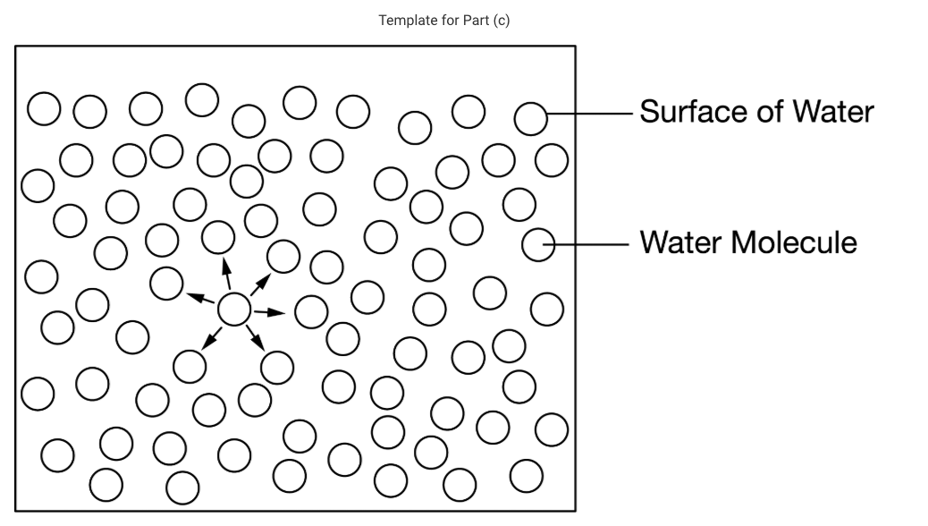

(d) The arrangement of the water molecules in ice causes the ice to float. Explain how ice floating on the surface of a body of water affects the water in a way that is beneficial to the organisms in it.

