Transcription and Translation Foldable Directions

Today you will make a foldable for DNA replication, Transcription, and Translation. Start with folding a piece of paper in the shutter fold style. See below:

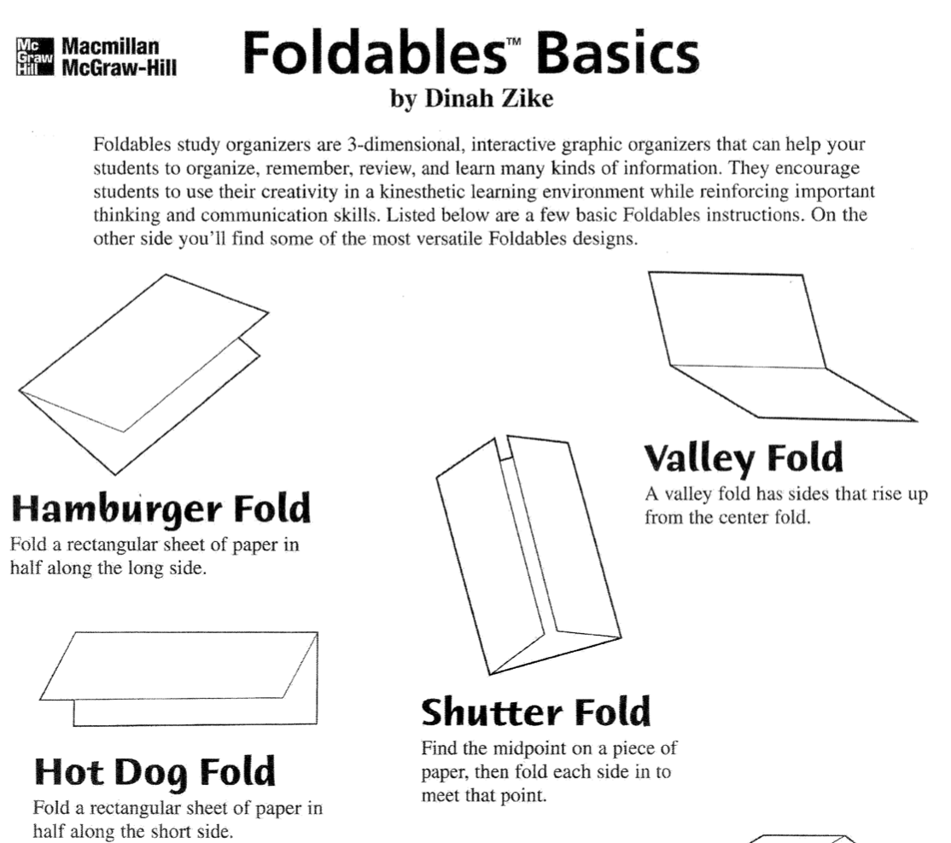

When your foldable has been correctly assembled, open the foldable to show the 3 parts. The first part (on the left) should have a title and description for Glycolysis. Use the notes to write and draw out what steps happen in DNA Replication. Include the steps which have DNA Helicase and DNA Polymerase. Describe what is produced at the end. The middle fold should have a title and steps for the Transcription. Draw out what is happening including what is used and what is produced. Include RNA polymerase and show the mRNA that is produced. The fold on the right should have a title for Translation and the steps which occur. Draw out a diagram of what happens. Include the ribosome, tRNA, rRNA and the building of a protein by assembling amino acids together. On the front of the foldable create a title and design. Be sure to include your name.

