General Biology B: Test Study Guide: Unit 1 – DNA

Objective 1: Describe the structure of the DNA nucleotide and its place in the double helix
Students will be able to:
1) Diagram the following structures: nucleotide, base pair, nitrogenous base, phosphate group,
deoxyribose, and ribose.
2) Describe the differences between purines and pyrimidines.
3) Describe the differences in bonds holding the structures together.
4) Describe the overall shape and structure of DNA.

How to study:
a) Read pages: 220-223.

b) Define the following terms:
- Nucleotide:
- Nitrogenous Base:
- Purine:
- Pyrimidine:
- Adenine:
- Thymine:
- Cytosine:
- Guanine:
- Hydrogen bonds:
- Covalent bonds:
- Base pair:
- Double helix:

c) You should be able to draw the parts of this diagram from memory: Figure 2.1 on Page 221.
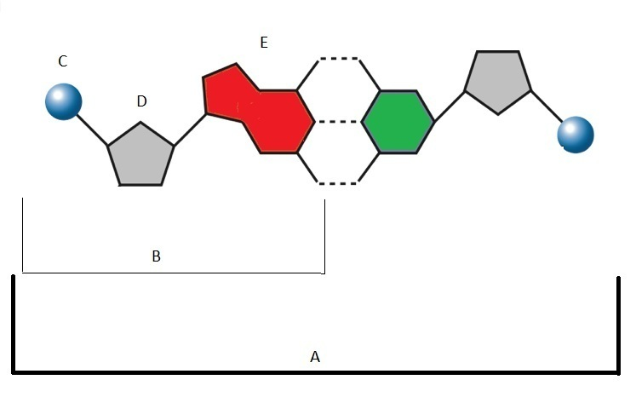

Objective 2: Explain the pairing and sequencing of the nitrogenous bases and the process of DNA replication

Students will be able to:
1) Describe the different nitrogenous bases in DNA.
2) Explain how the bases are paired.
3) If given a strand of DNA, be able to draw a replicated strand of DNA which corresponds to the
original.
4) Describe the steps of the DNA replication process.
5) Identify and explain the function of each enzyme involved.
6) Describe what is used and what is produced at the end of the replication process.
7) Describe when DNA replication occurs and explain why is needed for cells.

How to study:
a) Read Pages: 220-228.

b) Define the following terms:
- Nucleotide:
- Nitrogenous Base:
- Purine:
- Pyrimidine:
- Adenine:
- Thymine:
- Cytosine:
- Guanine:
- Hydrogen bonds:
- Covalent bonds:
- Base pair:
- Double helix:
- DNA helicase:
- DNA polymerase:
- Free nucleotides:
- Replication fork:
- Enzyme:

c) You should be able to draw and label the parts of this diagram from memory: Figure 3.1 on
Page 227.
d) You should be able to draw the parts of this diagram from memory: Figure 2.1 on Page 221.

Objective 3: Explain the process of transcription.

Students will be able to:
1) Describe the process of transcription.
2) Describe the role of DNA, mRNA, tRNA, and rRNA.
3) Diagram the structures of DNA, mRNA, tRNA, and rRNA.

How to study:
a) Read Pages: 229-237.

b) Define the following terms:
- DNA nucleotide:
- RNA nucleotide:
- Nitrogenous base:
- Purine:
- Pyrimidine:
- Adenine:
- Thymine:
- Cytosine:
- Guanine:
- Hydrogen bonds:
- Covalent bonds:
- Base pair:
- Codon:
- Uracil:
- mRNA (messenger RNA):
- tRNA (transfer RNA):
- rRNA (ribosomal RNA):
- Anti-codon:
- Transcription:
- Translation:
- RNA polymerase:
c) You should be able to draw and label the parts of this diagram from memory: Figure 4.2 on
Page 231.

Objective 4: Explain the process of translation and how proteins are synthesized.

Students will be able to:
1) Describe the steps to transcribe an mRNA molecule and use the mRNA molecule to produce
proteins.
2) Differentiate between transcription and translation.
3) Diagram the steps and illustrate what happens in each stage.

How to study:
a) Read Pages: 233-237.

b) Define the following terms:
- DNA nucleotide:
- RNA nucleotide:
- Nitrogenous base:
- Purine:
- Pyrimidine:
- Codon:
- Uracil:
- mRNA (messenger RNA):
- tRNA (transfer RNA):
- rRNA (ribosomal RNA):
- Anti-codon:
- Transcription:
- Translation:
- RNA polymerase:

c) You should be able to draw and label the parts of these diagrams from memory: Figure 5.1 on
Page 235 and Figure 5.4 on Page 236.

Objective 5: Explain the function of DNA (expressed and non-expressed).

Students will be able to:
1) Describe the function of DNA.
2) Explain how body cells contain all the DNA but use different genes for different purposes.
3) Describe how a cell uses different genes to function.
4) Describe how one gene can produce several different types of proteins.

How to study:
a) Read Page: 199.
Read Pages: 242-243.
b) Define the following terms:
- Gene:
- Exons:
- Introns:

Objective 6: Explain how the environment can influence the expression of traits.

Students will be able to:
1) Explain how and why genes are expressed.
2) Provide examples of internal factors which can influence gene expression.
3) Provide examples of external factors which can influence gene expression.
4) Describe how a cell uses different genes to function.
5) Describe how one gene can produce several different types of proteins.

How to study:
a) Read Page: 199.
Read Pages: 242-243.

b) Define the following terms:
- Gene:
- Exons:
- Introns:

Objective 7: Describe how mutations occur and the various types.

Students will be able to:
1) Describe the different types of chromosomal, frameshift, and point mutations.

How to study:
a) Read Pages: 244-247.

b) Define the following terms:
- Chromosomal mutation:
- Frameshift mutation:
- Point mutation:
- Translocation:
- Inversion:
- Insertion:
- Deletion:

c) You should be able to understand and interpret Figure 7.2 found on Page 245.

