Name: ____________________________________ Period:____________________

Instructions:
-Use the Scantron Form to answer the multiple-choice questions.
-Below: Answer 2 of the 3 short long questions. Also answer 1 of the 2 long response questions.

SHORT ANSWER QUESTIONS: (choose 2 of the 3 options) 10 pts each.

25. Describe the differences between a monophyletic, paraphyletic, and polyphyletic tree.

Identify which tree is monophyletic, paraphyletic, and polyphyletic. For example: group 1 is monophyletic etc.

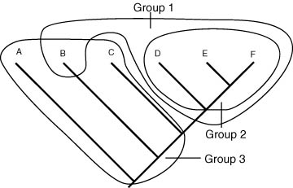
---------------------------------------------------------------------------------------------------------------------
26. Describe 5 attributes of organisms of the domain bacteria.

Describe 5 attributes of organisms of the domain Archaea

Explain the evolutionary relationship between Bacteria and Archaea.

------------------------------------------------------------------------------------------------------------------
27. Describe 3 characteristics each groups of protist (Algae, Slime molds, and protozoa).

Describe how each group resembles another group of organism (animals, fungi, plants etc).

LONG RESPONSE QUESTIONS: Choose 1 of the 2 options (10 pts).

28. Describe the lytic pathway of a virus and compare it with the lysogenic pathway of a virus.

------------------------------------------------------------------------------------------------------------------
29. Fungi have unique reproductive cycles. Explain the reproductive cycle and main structures of Basidiomycota.

