Name: ____________________________________ Period:____________________

Instructions:
-Use the Scantron Form to answer the multiple-choice questions.
-Below: Answer 2 of the 3 short long questions. Also, answer 1 of the 2 long response questions.

SHORT ANSWER QUESTIONS: (choose 2 of the 3 options) 10 pts each.

22.
a) Describe why a cell would need to replicate their DNA and when does replication occur?

b) Identify the enzyme which allows the following process to occur?

1. ___________________ separates the strands of DNA in preparation for replication?

2. ___________________ checks for errors and fixes mutations

3. ___________________ identifies the area of the DNA strand in which the replication will start.

4. ___________________ seals the lagging strand as it is broken into sections

5. ___________________ adds free nucleotides on both sides of the leading and lagging strands

c) Using the numbers above, list the correct sequence in which DNA replication occurs. Example 2,4,5,1,3.

---------------------------------------------------------------------------------------------------------------------
23.
a) In two to three sentences, describe the basics of the central dogma of genetics.

b) Explain how one sequence of DNA can be used to produce several different types of proteins.

c) In some cases, a single nucleotide mutation does not lead to the creation of a different protein. In two or three sentences, explain how this can happen.

------------------------------------------------------------------------------------------------------------------
24.
a) Differentiate between the following RNA molecules (mRNA, tRNA, rRNA). Identify their purpose, their structure, and their contribution to the making of a polypeptide chain.

b) Describe 3 differences between DNA and RNA molecules.

LONG RESPONSE QUESTIONS: Choose 1 of the 2 options (10 pts).

25. a) Describe 3 differences in translation in prokaryotes vs eukaryote cells.

b) We discussed in class the 1 gene- 1 protein idea. Describe 2 challenges which make it difficult for scientists to define what a gene does.

c) The DNA code is used as a template to make the mRNA transcript. That transcript is then used to produce a polypeptide sequence of amino acids. Given the following DNA sequence, what would the resulting polypeptide sequence be. TACGCACATTTACGTACGCGG

Use the Amino Acid table on the back page.

------------------------------------------------------------------------------------------------------------------
26.
a) Identify the following structures in a DNA molecule with the associated letter in the diagram:

Nucleotide: ____________

Purine: ____________

Covalent Bond: ____________

Phosphate group: ____________

Deoxyribose: ____________

Hydrogen Bond: ____________

Pyrimidine: ____________

Base Pair: ____________
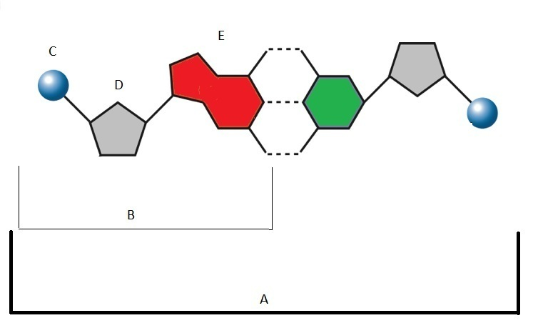
F
G
H

b) Describe the steps of DNA replication, include the enzymes used.

Amino Acid Table for mRNA Code
