Name: ____________________________________ Period:____________________

Instructions:
-Use the Scantron Form to answer the multiple-choice questions.
-Below: Answer 2 of the 3 short long questions. Also answer 1 of the 2 long response questions.

SHORT ANSWER QUESTIONS: (choose 2 of the 3 options) 5 pts each.

17)
a) Describe the difference between sexual reproduction and asexual reproduction.

b) Describe 2 advantages and 2 disadvantages of each type of reproduction

18) Meiosis in females is called Oogenesis. Match the cell type with what happens.

A. _______________ Diploid cells which have replicated DNA. From here they undergo meiosis I.

B. _______________ Diploid cells which still need to undergo the S-phase in interphase.

C. _______________ Haploid cells which have 23 chromosomes (in humans). They have undergone meiosis II.

D. _______________ Haploid cells which have 23 chromosomes (in humans). They have just finished Meiosis I, been fertilized, and proceed into Meiosis II through the fallopian tube.

E. _______________ These cells are not used for reproduction. They contain little cytoplasm or organelles. They degenerate quickly.

Word Bank
Polar body
Ovum

Primary Oocyte
Germinal cell
Secondary Oocyte

19) Four genes, J, K, L, M, reside on the same chromosome. Given that the crossover frequency between K and J is 3, between K and L is 8, between J and M is 12, and between L and M is 7. What is the order on the chromosome?

LONG RESPONSE QUESTIONS: Choose 1 of the 2 options (10 pts).

20. In cocker spaniels the genotype A-B- is black, aa B- is silver, A- bb is red, and aa bb is lemon. A black cocker is mated to a lemon one and produces a lemon pup. If this black dog is mated to another of its own genotype what proportions of the different colors would be expected in the offspring? Show your work with the Punnett square.

------------------------------------------------------------------------------------------------------------------
21.
a) Identify the stage of meiosis in the following cells:

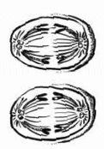
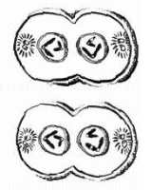
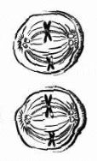

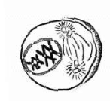

Stage: __________ Stage: ____________ Stage: ___________ Stage: ____________

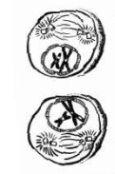

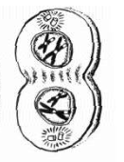
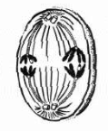
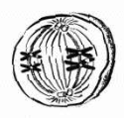

Stage: __________ Stage: ____________ Stage: ___________ Stage: ____________

b) Describe the function of meiotic daughter cells and the organs where meiosis takes place

c) Describe the contributions in meiosis to genetic variation

