24. a) Describe how an ionic bond forms.

b) Draw a diagram of the electron configuration of an atom of Na (atomic number 11) and the electron configuration of Cl (atomic number 17).

c) Explain how Na and Cl interact and form an ionic bond.

3 points for description of an ionic bond
3 points for a correct electron configuration of Na, 3 points for correct electron configuration of Cl.
3 points for description of movement of electrons and the identification of a positive and negative charge.
2 points for describing how the positive and negative form an ionic bond between them.

Total points possible (14 points)

25. There are 4 macromolecules which make up living organisms. For each macromolecule, identify the macromolecule, discuss their general structure, and provide an example of each.
Macromolecule | General Structure: | Example:

1 point for each macromolecule
1 point for general structure
1 point for each example

Max 12 points

26. Briefly describe the structure of primary, secondary, tertiary, and quaternary proteins and provide an example of each.

2 pts for correct description of each structure type. Max 8 pts
1 pt for correct example of each structure type. Max 4 pts
(Max 12 pts)

LONG RESPONSE QUESTIONS: Choose 1 of the 2 options (10 pts).
27. Discuss each of the following:
A) The structure of an enzyme
B) How enzymes function
C) How enzymes are regulated or affected by environments
1 Point for correct identification of the following: Tertiary structure, active sites, substrate, protein (Max 4 points)
1 Point for correct function of active site to substrate, cofactors, coenzymes, inorganic cofactors, activation energy, catalyst, rates of reaction, hydrolysis (Max 6 points)
1 Point for correct identification of temperature or pH. (Max 2 points)
2 points for explanation about how temperature and/or pH can affect enzyme effectiveness. Enzymes have an optimal temperature and pH in which they function the best. (Max 4 points)

Total points possible (16 points)

28. - The diagram shows water molecules as solid ice at 0˚C and as a liquid at 25˚C.
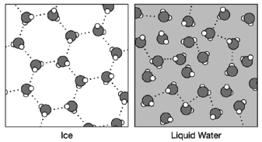
(a) Describe why hydrogen bonds form between water molecules.
(b) Explain why the arrangement of water molecules is different in ice and water.
(c) To help explain surface tension, use a single water molecule in the template and draw arrows representing the possible locations of hydrogen bonds formed by the molecule. The possible hydrogen bonds formed by a water molecule below the surface are shown.

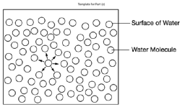
(d) The arrangement of the water molecules in ice causes the ice to float. Explain how ice floating on the surface of a body of water affects the water in a way that is beneficial to the organisms in it.
2 points for identifying a positive H area and negatively oxygen area in a water molecule.
1 point for identifying water is polar.
2 points for connecting a positive area of one molecule to the negative of another.
1 point for identifying that water can connect up to 3 H bonds with other water molecules.
1 point for identifying the term cohesion. (Max 4 points)

1 point for identifying H Bonds form a crystal structure and are stable in Ice.
1 point for identifying Liquid water H bonds constantly break and reform.
1 point for identifying that this allows the molecules to be more densely packed per surface area making it more dense. (Max 3 points)

3 points for identifying that water in liquid form will have less than 3 bonds per molecule. In liquid water the number will vary as it is constantly forming and breaking H bonds. (Max 3 points)

2 points for describing that life can exist under it.
2 points to identify floating ice acts as an insulator. (Max 4 Points)

Total possible points (14 points)

