**Unit 1: Chemistry of Life Focus Topics**

1) Electron configurations

2) Enzyme reactions

3) Types of protein structures

4) Macromolecule types and structures

5) 5 Properties of water

6) Balancing equations

7) Bond types: Hydrogen, Ionic, and Covalent

8) Hydrolysis vs Dehydration Synthesis

**Electron Configurations:**

Student can correctly diagram the electrons for an element: Na for example #11

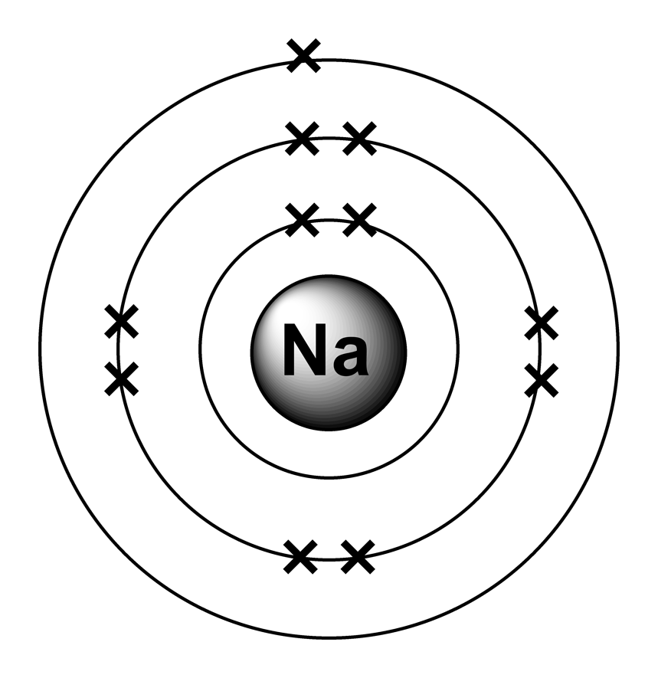

**Enzyme reactions:**

Student can explain the function of an enzyme, active site, substrate and how it is broken down. Why enzymes are important?

The **molecules** that **an enzyme** works with are **called substrates**. The **substrates** bind to a region on **the enzyme called** the active site. The lock-and-key model, the active site of **an enzyme** is precisely shaped to hold specific **substrates**. The reactions that occur accelerate greatly — over a millionfold — once the substrates bind to the active site of the enzyme. The chemical reactions result in a new product or molecule that then separates from the enzyme, which goes on to catalyze other reactions. They are important because they allow reactions in cells to go fast. Without them, our cells would die.

**Types of protein structures**

Student can describe the primary, secondary, tertiary, and quaternary structures and provide an example of each.

-Primary Structure is the unique sequence of which amino acids are joined. Example: Insulin

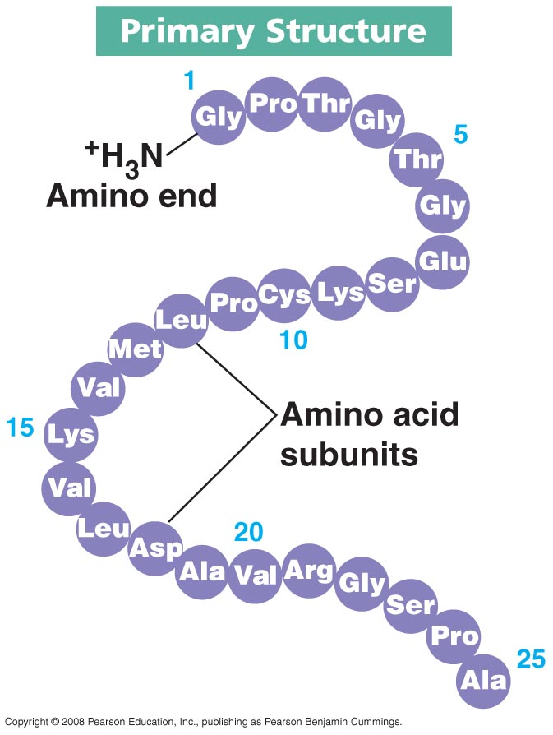

-Secondary Structure: one of two three-dimensional shapes that are the result of hydrogen bonding between members of the polypeptide backbone (not the amino acid side chains)

Alpha helix: a coiled shape much like a slinky

Beta pleated sheet: is like an accordion shape Example: Aquaporins, protein channels in the membrane of a cell

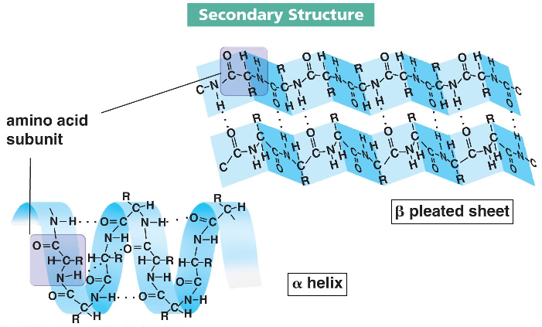

-Tertiary Structure: a complex globular shape due to interactions between the side chains (R groups), such as hydrophobic interactions, van der waals interactions, hydrogen bonds, and disulfide bridges. Example: enzymes.

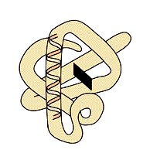

-Quaternary Structure: refers to the association of two or more polypeptide chains into one large protein. Hemoglobin is a globular protein with quaternary structure because it is composed of four chains. Example: Hemoglobin, DNA polymerase

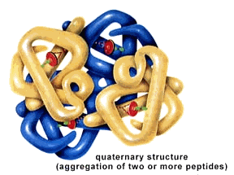

**Macromolecule types and structures**

Student can explain the function of each macromolecule types: Carbohydrates, Lipids, Nucleic Acids, and Proteins. Student can see a picture of the structure of a macromolecule and identify the general category. Student can give examples of each macromolecule type

-Carbohydrates (Sugars):

-Monosaccharides: The chemical formula for all monosaccharides is: CxH2xOx (1:2:1). glucose, fructose, galactose. See notes for pictures.

-Disaccharides: two monosaccharides bonded together. Example: Sucrose, Maltose, Lactose. See notes for pictures.

-Polysaccarides: The most complex carbohydrates which are made up of long chains of monosaccharides (glucose-like units). Starch, cellulose, and glycogen are examples. See notes for pictures.

-Lipids (waxes, fats, oils)

A group of organic compounds that include fats, oils, waxes, and related substances. Made of Carbon, hydrogen, and oxygen. There is no definite ratio of hydrogen to oxygen atoms like in carbohydrates. Hydrocarbons. Provide energy storage, protect vital organs, and insulation. Make up cell membranes. See notes for pictures.

-Nucleic Acids (DNA and RNA):

Their monomers are nucleotides. DNA is the molecule of heredity. See notes for pictures.

-Proteins (Enzymes):

Made of amino acids bonded together. They can be very large and complex. They play a wide variety of roles in the cell. Can be primary, secondary, tertiary, or quaternary in form.

Some are structural, others are hormones, enzymes, or pigments.

They are made off carbon, hydrogen, oxygen, and nitrogen; some contain sulfur. See notes for pictures.

**5 Properties of Water:**

Property 1: cohesion and adhesion (Identify)

-Linking of like (cohesion) and Linking of unlike (adhesion) (Definition)

-H bonding between H20 molecules or H bonding between H20 and other substances

-Creates surface tension or allows water to be pulled against gravity

-Example: Drinking straw, meniscus, capillary action, water spider walking on surface. (Example)

Property 2: good solvent (Identify)

-Solvent: The substance something is dissolved in. Solute: the substance being dissolved. Solution: The solvent mixed with the solute. Breaking down of a substrate. (Definition)

-Hydrophilic: water-soluble. Examples: solutions which dissolve in water. Example: many salts, sugars, polar molecules, some proteins. -Hydrophobic: water repelling. Example: lipids, oils which are nonpolar. Water is polar and can use that polarity to interact with hydrophilic molecules.

- Water molecules can pull apart proteins by using their polarity. Salts can be dissolved by water. Cl will be attracted to the positive Hydrogen areas, where as Na would be attracted to the negatively charged oxygen. Hydrocarbons are non-polar as they do not have an attraction to H20. Oils (Example)

Property 3: lower density as a solid, Ice Floats! (Identity)

-Due to lower density of H20 molecules per area, the solid form floats on the liquid (Definition)

-H Bonds form a crystal structure and are stable in Ice. Liquid water H bonds constantly break and reform. This allows the molecules to be more densely packed per surface area.

-Oceans and lakes don’t freeze solid providing habitat for organisms

-Surface ice insulates water below it allowing life to survive the winter

-Seasonal turnover of lakes; sinking cold H20 cycles nutrients in autumn. (Examples)

Property 4: High Specific Heat (Identify)

-Water resists changes in temperature and has a high specific heat. (Definition)

It takes a lot of energy to heat it up or cool it down (break/form H-bonds).

H20 moderates temperature on Earth and keeps climates stable for life (Examples)

Property 5: High Heat of Vaporization (Identify)

-A lot of energy is needed to heat water to a vaporization state (Definition)

-The amount of heat added to the water allows it to vaporize/evaporate easier. This removes heat in the body or surface

-Organisms rely on heat of vaporization to remove excess body heat. Sweating. (Example)

**Balancing equations**

Student can describe how an equation is balanced- Photosynthesis for example. Differentiate between atoms and molecules.

**Bond types: Hydrogen, Ionic, and Covalent**

Student can illustrate how a hydrogen, ionic, and covalent bond form. Can provide an example of each.

NaCl for Ionic, H20 for Covalent, H20 and H20 for Hydrogen.

**Hydrolysis vs Dehydration Synthesis**

Student can describe how molecules are broken down by hydrolysis and built by dehydration synthesis.

Hydrolysis is the use H2O to breakdown polymers. H2O is split into H+ and OH–

H+ & OH– attach to ends of products. It requires enzymes and releases energy.

Dehydration Synthesis: joins monomers by “taking” H2O out

-one monomer donates OH–

-other monomer donates H+

-together these form H2O

-requires energy & enzymes