Free Response Questions for Unit 10: Plants

Focus Topics:
Evolution of plants
General characteristics and examples of nonvascular plants
General characteristics and examples of seedless vascular plants
General characteristics and examples of gymnosperms plants
General characteristics and examples of angiosperms plants
Systems of Plants: General characteristics
Organs of Plants: General characteristics
Tissues of Plants: General characteristics
3 main cells of plants: General characteristics
Xylem and Phloem transport
Sexual and Asexual reproduction of angiosperms
Parts and Function of Flowers
Function of Fruit
Seed Germination of monocots/dicots

Evolution of plants
Green algae are the closest relatives of plants. Charophytes are a group of modern green algae. Biologists believe they are similar to the ancestors of plants.
DNA sequences reveal a close evolutionary relationship.
Chloroplasts contain the same pigments.
Cell walls contain cellulose.
Both use starch as a storage molecule.

General characteristics and examples of plants (Nonvascular, seedless nonvascular, gymnosperms, angiosperms)

Bryophytes: There are about 24,000 existing species of bryophytes, or “nonvascular” plants.
Mosses, hornworts, and liverworts are bryophytes. The earliest plants probably resembled modern bryophytes. Bryophytes have no vascular tissue, roots, leaves, seeds, or flowers. Without vascular tissue and lignin (which strengthens the cell wall), bryophytes lack physical support.
Materials move from cell to cell within the plant by diffusion and osmosis.
They live in moist shady habitats where they will not dry out.

Seedless vascular plants: There are about 12,700 existing species of plants with vascular tissue, but no seeds. This phylum is composed of ferns and their close relatives. Seedless vascular plants have true roots, stems, and leaves. Vascular tissue allowed these plants to grow much larger than bryophytes, which gave them an edge in competing for sunlight. Seedless vascular plants include: Club mosses, Whisk ferns, Horsetails, True ferns.

Gymnosperms: Gymnosperms are “naked seed” plants. New reproductive adaptations allowed gymnosperms to outcompete seedless vascular plants in many habitats. Gymnosperms produce seeds but do not enclose them in fruit. Gymnosperms include cycads, Ginkgo, Conifers, and Gnetophytes.

Angiosperms:
Angiosperms produce pollen and egg cells in flowers, which develop into fruit after fertilization. Scientists classify the diverse angiosperms into several groups, notably the eudicots and monocots. All flowering plants including roses, grasses, fruit trees, maples, and oaks.

Systems of Plants: General characteristics

Shoot System (everything above the ground) and Root System (everything below the ground)

Organs of Plants: General characteristics
Roots (Roots anchor the plant and absorb water and minerals that move via the stem to the leaves), stems (support the leaves), leaves (Produce carbohydrates via photosynthesis)

Tissues of Plants: General characteristics
Ground tissue makes up most of the plant body.
-Ground tissue consists of three main cell types: parenchyma, collenchyma, and sclerenchyma.
-The cells that compose ground tissue are important sites of photosynthesis, respiration, storage, and support.

Vascular tissues (xylem and phloem) transport materials within the plant.
- Xylem tissue transports water and minerals from the roots to other plant parts. It consists of long, narrow cells called tracheids and wide, barrel-shaped cells called vessel elements.
- Phloem tissue transports dissolved organic compounds like sugars. Sieve tube elements are the conducting cells; they are separated by sieve plates. Companion cells transfer materials in and out of sieve tubes.

Dermal tissue covers the plant.
-it consists of the epidermis, which is coated with a waxy cuticle.
- The cuticle conserves water and protects the plant. Pores in the cuticle, called stomata, allow leaves to exchange gases with the atmosphere.
- Guard cells surround each stoma and control its opening and closing.

3 main cells of plants: General characteristics
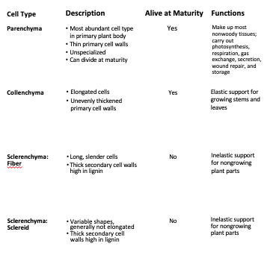
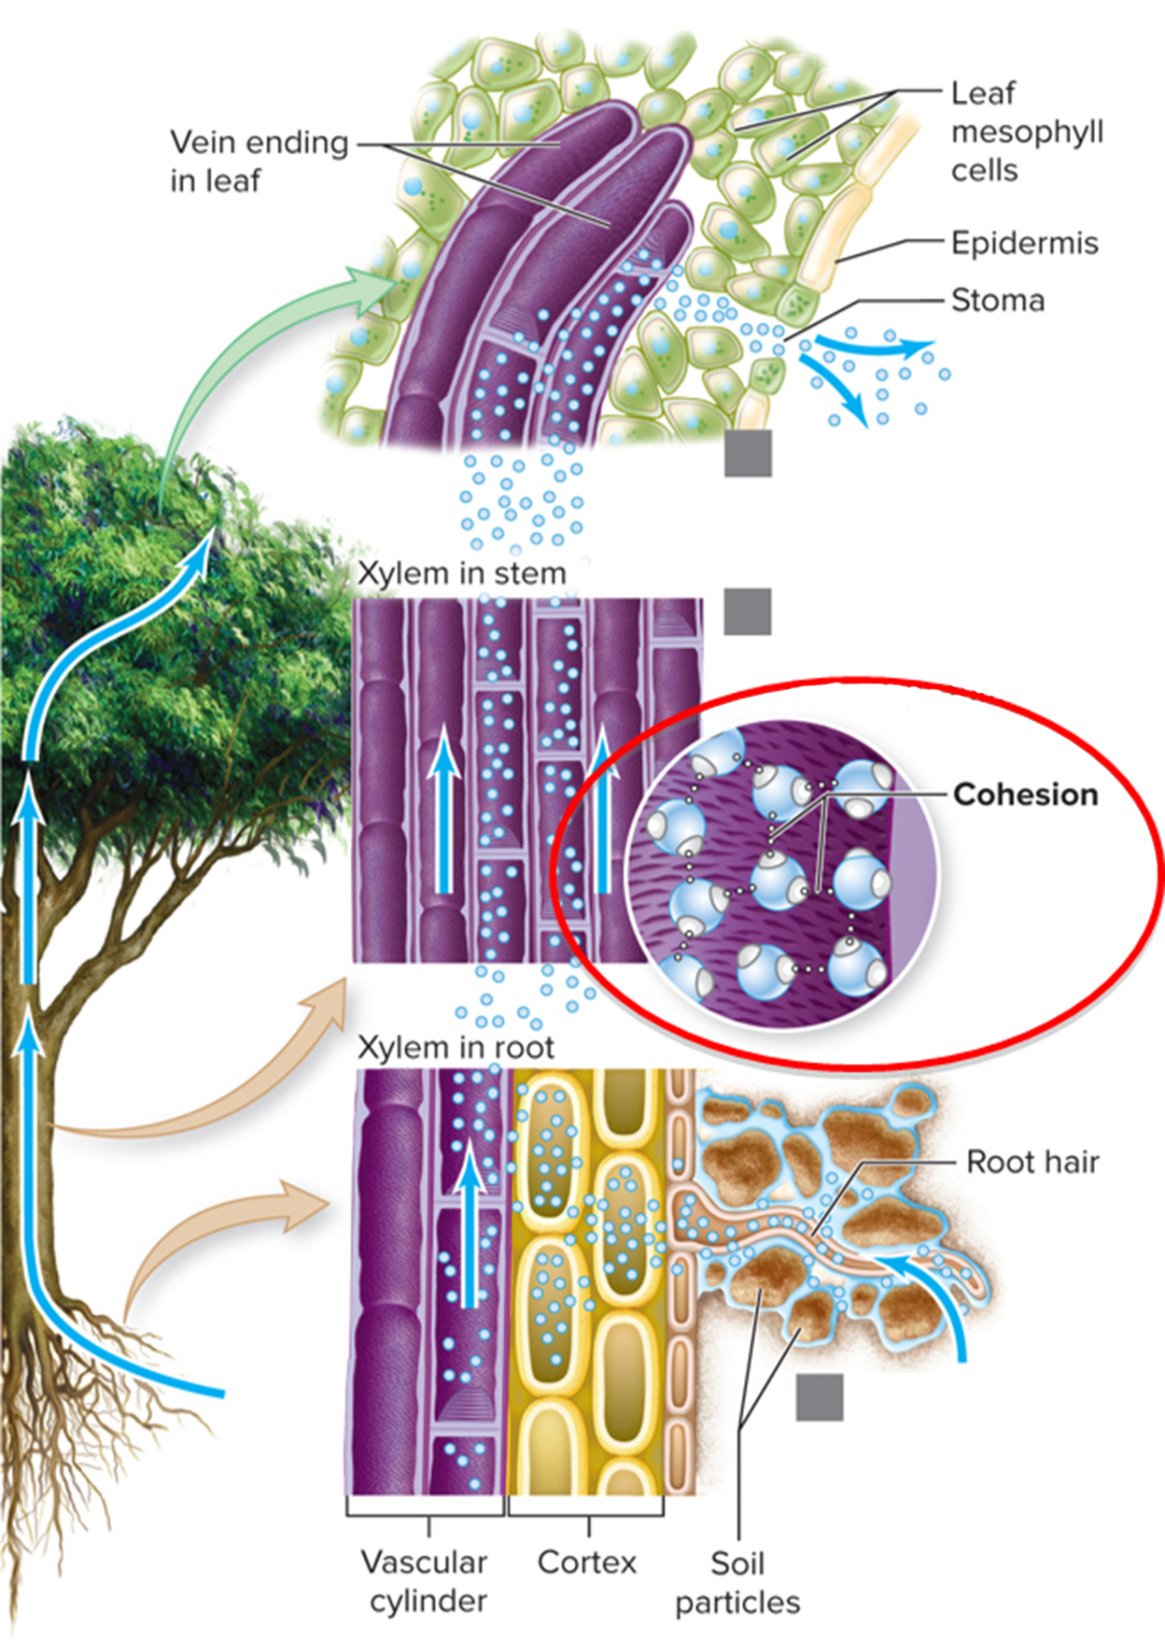

Xylem and Phloem Transport
- Xylem tissue transports water and minerals from the roots to other plant parts. It consists of long, narrow cells called tracheids and wide, barrel-shaped cells called vessel elements.
- Phloem tissue transports dissolved organic compounds like sugars. Sieve tube elements are the conducting cells; they are separated by sieve plates. Companion cells transfer materials in and out of sieve tubes.

Parts and Function of Flowers:
The outer whorl is the calyx. It consists of sepals, which enclose and protect the inner floral parts.
The second whorl is the corolla, which is made of petals.
The third whorl is the male reproductive parts. Stamens are filaments with pollen-producing anthers on top.
The fourth whorl is the female reproductive parts. A carpel includes:
-the ovary, which encloses one or more ovules.
-a stalk-like style. The top of the style, called the stigma, receives pollen.
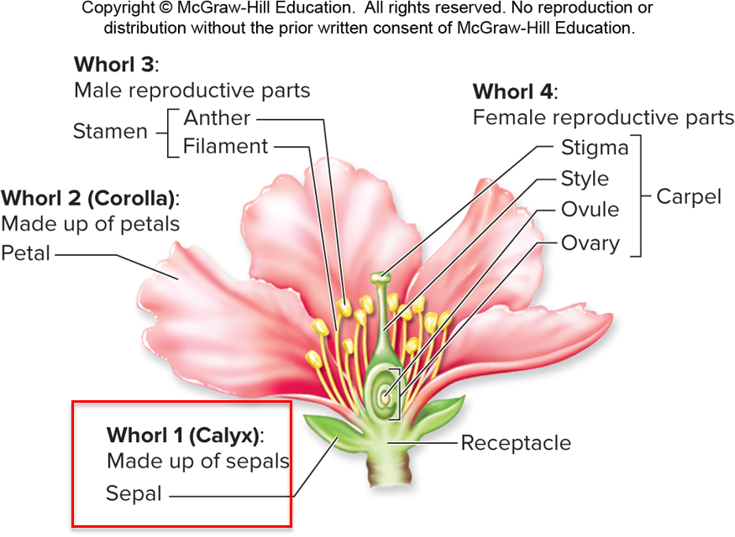

Sexual and Asexual Reproduction for Angiosperms
Flowers and seeds are produced by angiosperms that sexually reproduce, yielding genetically unique offspring
with traits derived from two parents. Some species of angiosperms also reproduce asexually, forming new individuals by mitotic division. Offspring produced asexually are genetically identical to each other and to their parents. These aspen trees can reproduce either asexually, as suckers grow from roots, or sexually via seeds. Similarly, the leaves of this kalanchoe plant produce genetically identical plantlets. Asexual reproduction is advantageous when conditions are stable and plants are well-adapted to their surroundings. Sexual reproduction produces variable offspring, increasing reproductive success in a changing world.

Function of Fruit:
At the same time, a fruit develops from the ovary enclosing the developing seed(s). Fruits protect and disperse seeds. Seeds carried away from parent plants decrease the chance of competition among parents, offspring, and siblings. Unripe fruits, which contain immature seeds, are usually distasteful. Ripe fruits are tasty; mature seeds are deposited in droppings. Prickly fruits stick to feathers or fur. Some fruits catch the wind with tufts of fluff.
Still others float in water currents.
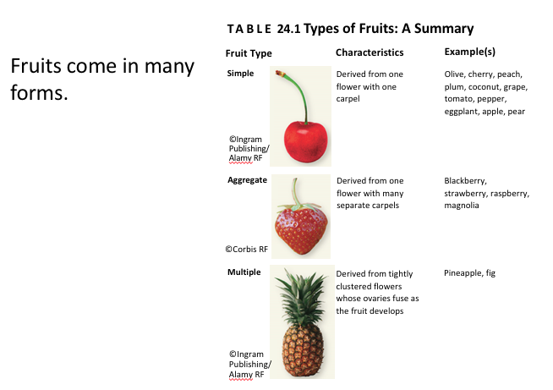

Seed Germination:
Continued development requires seed germination, the resumption of growth and development after a period of seed dormancy. Germination requires water, $O_{2}$, and a favorable temperature. The seed absorbs water and swells, rupturing the seed coat and exposing the embryo to $O_{2}$. Meanwhile, enzymes break down the endosperm’s starch into sugars.
The availability of $O_{2}$ and sugars means cellular respiration can resume in the embryo. Cell division at apical meristems rapidly lengthens the young roots and shoot. At first, the only energy source is fuel stored in the endosperm. After the shoot emerges from the ground and the first leaves unfold, photosynthesis begins. Monocots and eudicots, two groups of plants, have slightly different development patterns.
