The Speciation of Darwin Finches on the Galapagos Islands
Introduction
Two million years ago, finches (Genus Geospiza) flew from South America to the Galapagos Islands, a 900 kilometer trip. Each Galapagos Island had a population of finches from South America. A population is a breeding group of individuals. All populations of organisms including the Galapagos Island finches exhibit slight differences, Genetic Variation, between individuals. The variations are sometimes obvious outside features like beak shape, but also internal differences that are not easy to see. The feature Charles Darwin studied and the basis of this lab is the difference in Finch beak shape.
Evolution is described as a change in a population of organisms over time. The original Galapagos finch populations showed considerable variation in beak shape between individuals. Some individuals had beak shapes that made obtaining food easy, while other beak shapes made obtaining food more difficult. Natural Selection is when an environment favors ONE individual’s variation over another (the strong or best fit individual survives). Darwin believed that over time, the Galapagos island available food favored one individual beak shape over the other shapes. This natural selection, changed the island finch population’s characteristics resulting in evolution.
Darwin proposed that as each island’s finch populations changed in a unique manor due to the type of food present on that island. The separate island finch populations became increasingly different from one another. One original South American finch eventually evolved into 13 different finch species, each perfectly adapted to a different island. Speciation is the formation of new species due to the evolution or change in a population.
The Galapagos Islands
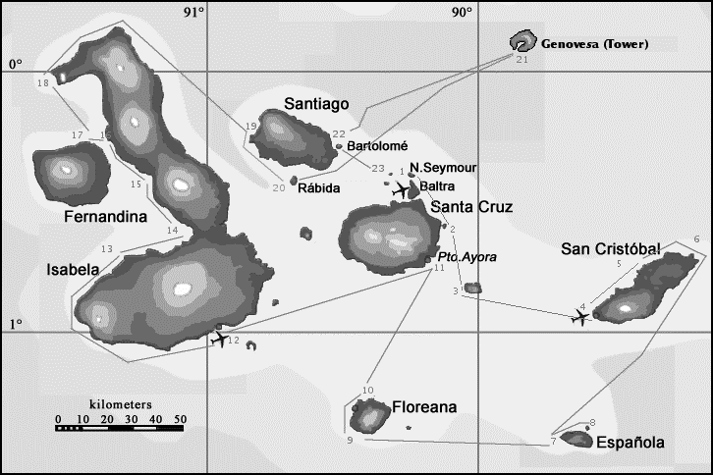
- Fernandina
- Isabella
- Santiago
- Bartolome
- Rabida
- N. Seymore
- Baltra
- Santa Cruz
- Pto. Ayora
- San Cristobal
- Floreana
- Espanola
- Genovesa

Procedure; Factors involved in Speciation
- Each table is an island. Take out the contents of the island box and place in the center of the island. Please do not touch the materials until told to do so.
- 1 student on each island should be the designated timer and use his/her cell phone to time portions of the lab. A different student should be the recorder and record the results on the lab answer sheet. Another student should be the reader and have instructions. The reader reads the lab out loud, starting now.
- A Population of Island Finches; each student is part of the finch population of the island. Every student should obtain and read 1 South American Finch card (viable offspring box).
- Variation; each island population initially has diverse (many different) finch beak shapes. Student finches should select 1 beak from the beak bag. Each student finch should have a different beak shape (tool). The recorder should fill out column 2 on the data chart. Be sure to fill-in the correct chart for the island you are currently on!
- Natural Selection; the unique environment of each island will result in the death of some finches due to starvation. The individuals suited to the environment survive and reproduce.
- The food available on the particular island is found in the middle of the island. The container for the food source may not be touched or pushed around.
- Each student uses their appropriate tool to obtain food for 1 minute, placing obtained food into their food cup. The recorder should set the time for 1 minute and all finches will attempt to put food into their cup during this time.
- The reader should read out-loud the special island rules for that particular island. Before proceeding, the teacher should approve the island set-up.
- Obtain food for the appropriate amount of time.
- The student finch with the least amount of food dies. The dead finch must return their beak tool to the beak bag. In case of a tie, do rock-paper-scissors to determine the loser.
- The finches with the 2nd most, third most, and 4th most amount of food obtained enough food to live but not reproduce.
- The 1 finch with the most food lives and reproduces. In case of a tie, do rock-paper-scissors to determine the loser.
- The dead finch now becomes the offspring of the winner finch and selects a finch beak like his parent. The recorder should fill in the next column in the data chart.
- Return all food (empty finch food cups).
- Repeat steps 9-14 until all columns in the chart are filled.
- Isolation; the surviving finches tend to stay on the island and never mix with other island finches. As each island finch population becomes more different than other island finch populations the finches may eventually choose NOT to associate with other finch populations. At this point, a new species of finch has evolved, Speciation.
- Pass out to each student finch a complete set of finch species cards (5 different finch species cards per person). Use collaboration and the process of elimination to decide which finch species evolved on your island. Record the result in the data chart.
- Clean-up the island. Move to the next island.
- Change who is the recorder, timer, and reader and repeat the lab.

