General Biology

Ecology Unit Objectives: Study Guide for Test

Objective 1: Describe the biotic and abiotic factors which limit population sizes

Students should be able to:
-Identify ecological factors that limit population growth.
-Describe how biotic and abiotic factors limit population sizes
-Describe how density dependent factors and density independent factors influence the population size of a species
-Describe how stable conditions can lead populations to maintain population sizes and species.
-Describe how extreme conditions can change the size of any population and challenge the functioning of ecosystems in regard to resources and habitat availability

1) Read Pgs: 432-436 Chapt 14.4; 394 chapt 14.2

2) Vocabulary Terms to Know:
-Limiting factors cause a populations growth to slow. They include availability of food, predators, lack of space etc.
-Abiotic factors are non-living factors which can influence population growth. Such as temperature, availability of water etc.
-Biotic factors are all living things that live in an environment.
-Density Dependent Factor: They include disease, competition, predators, parasites, and food. These factors have an increasing effect as the population increases.
-Density Independent Factor: can affect populations regardless of their size or density. They include abiotic factors such as volcanic eruptions, temperature, storms, floods, drought, chemical pesticides, and major habitat disruptions. They are not dependent on population size.
-Carrying capacity is the maximum number of individuals that an environment can support.
-Life History Pattern: An organism’s reproductive pattern. They include Rapid life-history patterns where organisms have small body size, mature rapidly, reproduce early, and have short life spans. (example: mosquitos); Slow life history patterns are larger species that live in stable environments. They reproduce and mature slowly and are long-lived. They maintain population sizes at or near the carrying capacity. (example: elephants)

3) Diagrams to know: Fig 4.1, Fig 4.3, 4.5

Objective 2: Explain carrying capacities which limit organisms and populations in ecosystems.

Students should be able to:
-Define carrying capacity and describe how it varies with the changes in the environment
-Describe how changes in carrying capacity and limiting factors can change population density.
-Describe how changes in a population’s size are determined by immigration, births, emigration, and deaths.
-Explain how population growth is based on available resources.

1) Read Pgs: 432-436 Chapter 14.4

2) Vocabulary Terms to Know:
-Carrying capacity is the maximum number of individuals that an environment can support.
-Immigration is the movement of individuals into a population from another population.
-Emigration is the movement of individuals out of a population and into another population
-Exponential growth: The type of growth which occurs when a population size increases dramatically over a period of time. It appears as a J-shaped curve
-Logistic growth: The type of growth where the population begins with a period of slow growth followed by a brief period of exponential growth before leveling off at a stable size. A graph of logistic growth takes the form of an S-shaped curve
-Population crash is a dramatic decline in the size of a population over a short period of time.

3) Diagrams to know: Fig 4.1, Fig 4.3, 4.5

Objective 3: Describe the levels of a food web

Students should be able to:
-Explain how energy is passed from one trophic level to the next.
-Describe the parts of a food web and food chain

1) Read Pgs: 400-403 Chapt 13.4

Food Web: A model which demonstrates the flow of energy in an ecosystem. It shows all the possible feeding relationships at each trophic level.
Food Chain: a simple model that scientists use to show how matter and energy move through an ecosystem.
Predator-Prey relationship: Predators are types of consumers which seek out and eat other organisms. Prey are the organism which is being eaten by a predator.
Trophic Level: a feeding step in a food chain which allows the passage of energy and materials.
Producer: An organism that makes its own food (autotroph). Example: Plants
Consumers: An organism that gets their energy by eating other organisms (heterotroph). Example: mice, starfish, humans, ants
Herbivores: Consumers which only eat producers. (Plant eaters). Cows, sheep, deer, grasshoppers
Carnivores: Consumers that eat only other consumers (flesh eaters). Examples: Lions, hawks, spiders
Omnivores: Consumers that eat herbivores, carnivores, and producers. (Eater of all) Examples: Bears, Pigs, Humans
Decomposers: Consumers that get their food by breaking down dead organisms, causing them to rot. Examples: Fungi, Bacteria

3) Diagrams to know: Fig 4.1; 4.3 Chapter 13.4

Objective 4: Explain why there are fewer organisms at high levels of a food web.

Students should be able to:
-Explain how only a small fraction of the matter available is passed upward to the next level to produce growth and release energy in cellular respiration
-Describe the conservation of atoms/molecules of carbon, oxygen, hydrogen, and nitrogen as they move through an ecosystem
-Explain why there are fewer organisms at high levels of a food web
-Explain the difference between populations, species, communities, and ecosystems.
1) Read Pages: 411-413 Chapter 13.6

2) Vocabulary to know:

Food chain: A sequence in which energy is transferred from one organism to the next as each organism eats another. Example: Algae->Krill->Cod->Leopard Seal->Killer Whale.
Trophic Level: Each step in the transfer of energy through an ecosystem.
Food web: A collection of food chains which shows many of the feeding relationships in an ecosystem. See fig 3-7 Pg 60.
Producer: An organism that makes its own food (autotroph). Example: Plants
Consumers: An organism that gets their energy by eating other organisms (heterotroph). Example: mice, starfish, humans, ants
Autotroph: An organism which produces its own food (Producer).
Heterotroph: An organism which eats another organism. Example: Deer eats grass.
First-Order Heterotroph: A heterotroph which eats a producer. Example: Deer eats grass.
2nd-Order Heterotroph: A heterotroph which eats a 1st order heterotroph. Coyote eats deer which ate grass.
3rd-Order Heterotroph: A heterotroph which eats a 2nd order heterotroph. Bear eats coyote which ate deer, which ate grass.
Decomposers: Consumers that get their food by breaking down dead organisms, causing them to rot. Examples: Fungi, Bacteria
Scavenger: A heterotroph which eats dead organisms.
Energy Pyramid: An illustration which shows that there is less energy available on the top than on the bottom of the pyramid.
-Population: a group of organisms of the same species living within a defined area.
-Species: A group of organisms which can potentially interbreed successfully and produce offspring with similar characteristics and behavior as the parents.
-Community: All the populations of different species that live in the same place at the same time.
-Ecosystem: Populations of plants and animals that interact with each other in a given area and with the abiotic components of that area.

3) Diagrams to know: Fig 6.1, 6.2, 6.3 Chapter 13.6

Objective 5: Describe how human activity can disrupt and endanger species in an ecosystem including habitat destruction, pollution, introduction of invasive species, overexploitation, and climate change.

Students should be able to:
-Describe how human activity can disrupt and endanger species in an ecosystem including habitat destruction, pollution, introduction of invasive species, overexploitation, and climate change.
-Describe how human activity displaces habitat of species
-Explain how human activity pollutes the environment
-Describe how humans introduced invasive species to environments
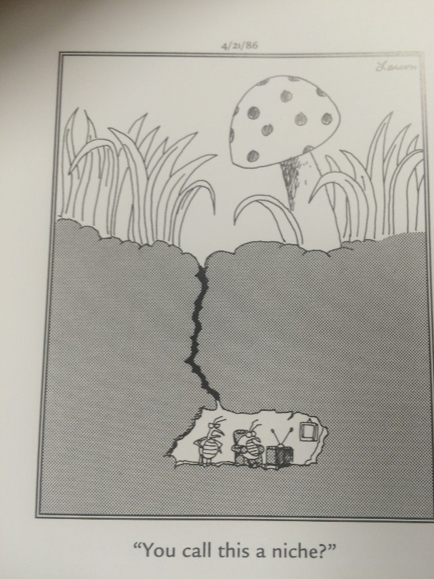
-Explain how human activity leads to overexploitation of resources
-Describe how human activity may be contributing to climate change.

1) Read Pages: 486-489 Chapt 16.4

2) Vocabulary to know:

Endangered Species: An endangered species is a species which has been categorized as very likely to become extinct.
Habitat: is the place where organism live out their lives
Niche: is how a species finds food and lives out its life.
Pollution: Pollution is the introduction of contaminants into the natural environment that cause adverse change
Invasive Species: are plants, animals, or pathogens that are non-native (or alien) to the ecosystem under consideration and whose introduction causes or is likely to cause harm.
Native Species: A species that normally lives and thrives in a particular ecosystem.
Climate change: is a change in the statistical distribution of weather patterns when that change lasts for an extended period of time

