Cell Respiration
Cell respiration refers to the process of converting the chemical energy of organic molecules into a form immediately usable by organisms. Glucose may be oxidized completely if sufficient oxygen is available by the following equation:
C₆H₁₂O₆ + 6O₂(g) → 6 H₂O + 6 CO₂(g) + energy
All organisms, including plants and animals, oxidize glucose for energy. Often, this energy is used to convert ADP and phosphate into ATP. It is known that peas undergo cell respiration during germination. Do peas undergo cell respiration before germination? The results of this experiment will verify that germinating peas do respire. Using your collected data, you will be able to answer the question concerning respiration and non-germinating peas.
Using the O₂ Gas Sensor, you will monitor the oxygen consumed by peas during cell respiration. Both germinating and non-germinating peas will be tested. Additionally, cell respiration of germinating peas at two different temperatures will be tested.

OBJECTIVES
In this experiment, you will
- Use an O₂ Gas Sensor to measure concentrations of oxygen.
- Study the effect of temperature on cell respiration.
- Determine whether germinated and non-germinated peas respire.
- Compare the rates of cell respiration in germinated and non- germinated peas.

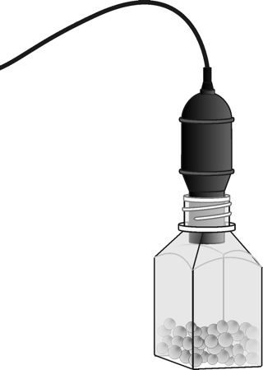
Figure 1
MATERIALS
computer | 25 germinating peas
Vernier computer interface | 25 non-germinating peas
Logger Pro | 250 mL respiration chamber
Vernier O₂ Gas Sensor | ice cubes
two 100 mL beakers | thermometer

PROCEDURE
1. Connect the O₂ Gas Sensor to the computer interface.
2. Prepare the computer for data collection by connecting the O2 sensor with the lab quest interface.
3. Obtain 25 germinating peas and blot them dry between two pieces of paper towel. Use the thermometer to measure the room temperature. Record the temperature in Table 1.
4. Place the germinating peas into the respiration chamber.
5. Place the O₂ Gas Sensor into the bottle as shown in Figure 1. Gently push the sensor down into the bottle until it stops. The sensor is designed to seal the bottle without the need for unnecessary force.
6. Wait two minutes, then begin collecting data by clicking . Data will be collected for 300 seconds.
7. When data collection has finished, remove the O₂ Gas Sensor from the respiration chamber. Place the peas in a 100 mL beaker filled with cold water and an ice cube.
8. Fill the respiration chamber with water and then empty it. Thoroughly dry the inside of the respiration chamber with a paper towel.
9. Determine the rate of respiration:
- On the Labquest, click on ANALYSE.
- Then tap on Curve Fit. Then Oxygen Sensor.
- On the drop-down menu, choose linear fit.

10. Record the slope of the line, m, as the rate of respiration for germinating peas at room temperature in Table 2. Close the linear regression floating box.
11. Obtain 25 non-germinating peas and place them in the respiration chamber
12. Repeat Steps 5–10 for the non-germinating peas.

Part II Germinating peas, cool temperatures
13. Remove the peas from the cold water and blot them dry between two paper towels.
14. Repeat Steps 5–9 to collect data with the germinating peas at a cold temperature.
DATA
Table 1
Condition | Temperature (°C)
room

Table 2
Peas | Rate of Respiration (%/min)
Germinating, room temperature
Non-germinating, room temperature
Germinating, cool temperature

Questions
1. Do you have evidence that cell respiration occurred in peas? Explain.

2. What is the effect of germination on the rate of cell respiration in peas?

3. What is the effect of temperature on the rate of cell respiration in peas?

- Why do germinating peas undergo cell respiration?

Cell Respiration
Cell respiration refers to the process of converting the chemical energy of organic molecules into a form immediately usable by organisms. Glucose may be oxidized completely if sufficient oxygen is available by the following equation:
C₆H₁₂O₆ + 6O₂(g) → 6 H₂O + 6 CO₂(g) + energy
All organisms, including plants and animals, oxidize glucose for energy. Often, this energy is used to convert ADP and phosphate into ATP. It is known that peas undergo cell respiration during germination. Do peas undergo cell respiration before germination? The results of this experiment will verify that germinating peas do respire. Using your collected data, you will be able to answer the question concerning respiration and non-germinating peas.
Using the CO₂ Gas Sensor, you will monitor the carbon dioxide produced by peas during cell respiration. Both germinating and non-germinating peas will be tested. Additionally, cell respiration of germinating peas at two different temperatures will be tested.

OBJECTIVES
In this experiment, you will
- Use a CO₂ Gas Sensor to measure concentrations of carbon dioxide.
- Study the effect of temperature on cell respiration.
- Determine whether germinated and non-germinated peas respire.
- Compare the rates of cell respiration in germinated and non- germinated peas.

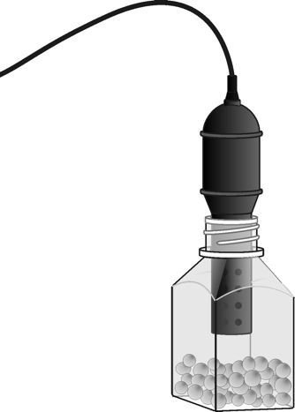
Figure 1
MATERIALS
computer | 25 germinating peas
Vernier computer interface | 25 non-germinating peas
Logger Pro | ice cubes
Vernier CO₂ Gas Sensor | thermometer
250 mL respiration chamber | two 100 mL beakers

PROCEDURE
1. If your sensor has a switch, set it to the Low (0–10,000 ppm) setting. Connect the CO₂ Gas Sensor to the lab quest interface
2. Prepare the computer for data collection by connecting the sensor to the lab quest interface
3. Obtain 25 germinating peas and blot them dry between two pieces of paper towel. Use the thermometer to measure the room temperature. Record the temperature in Table 1.
4. Place the germinating peas into the respiration chamber.
5. Place the shaft of the CO₂ Gas Sensor in the opening of the respiration chamber.
6. Wait one minute, then begin measuring carbon dioxide concentration by clicking . Data will be collected for 5 minutes.
7. Remove the CO₂ Gas Sensor from the respiration chamber. Place the peas in a 100 mL beaker filled with cold water and an ice cube. The cold water will prepare the peas for part II of the experiment.
8. Use a notebook or notepad to fan air across the openings in the probe shaft of the CO₂ Gas Sensor for 1 minute.
9. Fill the respiration chamber with water and then empty it. Thoroughly dry the inside of the respiration chamber with a paper towel.
10. Determine the rate of respiration:
- On the Labquest, click on ANALYSE.
- Then tap on Curve Fit. Then Oxygen Sensor.
- On the drop down menu, choose linear fit.

11. Record the slope of the line, m, as the rate of respiration for germinating peas at room temperature in Table 2. Close the linear regression floating box.
12. Obtain 25 non-germinating peas and place them in the respiration chamber
13. Repeat Steps 5–11 for the non-germinating peas.

Part II Germinating peas, cool temperatures
14. Remove the peas from the cold water and blot them dry between two paper towels.
15. Repeat Steps 5–11 to collect data with the cold germinating peas.
DATA
Table 1
Condition | Temperature (°C)
room

Table 2
Peas | Rate of Respiration (ppm/min)
Germinating, room temperature
Non-germinating, room temperature
Germinating, cool temperature

Questions
1. Do you have evidence that cell respiration occurred in peas? Explain.

2. What is the effect of germination on the rate of cell respiration in peas?

3. What is the effect of temperature on the rate of cell respiration in peas?

4. Why do germinating peas undergo cell respiration?

