Name: ___________________________________________ Period:___________________

Answer and Data Sheet for BLAST Lab (Natural Selection)
Example 1:
Use the following data to construct a cladogram for the major plant groups below the table.
Table 1: Physical Characteristics of Major Plant Groups
Plant Group | Vascular Tissue | Flowers | Seeds
mosses | 0 | 0 | 0
pine trees | + | 0 | +
flowering plants | + | + | +
ferns | + | 0 | 0
Draw the cladogram for the groups here:

Example 2:
GAPDH (glyceraldehydes 3-phosphate dehydrogenase) is an enzyme that catalyzes the sixth step in glycolysis, an important reaction that produces molecules used in cellular respiration. The following data table shows the percentage similarity of this gene and the protein it expresses in humans versus other species. For example, according to the table, the GAPDH gene in chimpanzees is 99.6% identical to the gene found in humans, while the primary sequence of the corresponding protein is identical.
Table 2: Percentage Similarity of the GAPDH Gene and Protein with Homo Sapiens
Species | Gene Percentage Similarity with Homo Sapiens | Protein Percentage Similarity with Homo Sapiens
Chimpanzee (Pan troglodytes) | 99.6% | 100%
Dog (Canis lupis familiaris) | 91.3% | 95.2%
Fruit fly (Drosophila melanogaster) | 72.4% | 76.7%
Roundworm (Caenorhabditis elegans) | 68.2% | 74.3%

Questions:
1) Draw a cladogram depicting the evolutionary relationships among all five species (including Humans) according to their percentage similarity in the GAPDH gene.

2) The following four alien species were discovered, and it was realized that species “A” is very primitive – therefore it is the outgroup for the bunch. Use the pictures of each species to answer the following questions.
a. Fill out the following character matrix with a “O” for the ancestral trait (outgroup), and a “+” for a derived trait (different than outgroup).
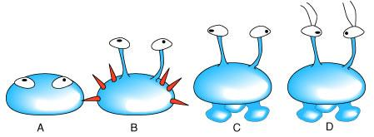

Physical Characteristic | SPECIES
 | A | B | C | D
Eyes present
Spines present
Eyes of stalks
“feet” present
Antennae present

b. Generate a cladogram from the above matrix in the space below. Label the position of the synapomorphies.

PART I – Using BLAST
1. Form an initial hypothesis as to where you believe the fossil specimen should be place on the cladogram based on the morphological observations you made earlier. Draw your hypothesis on the cladogram to the right (Figure 4).
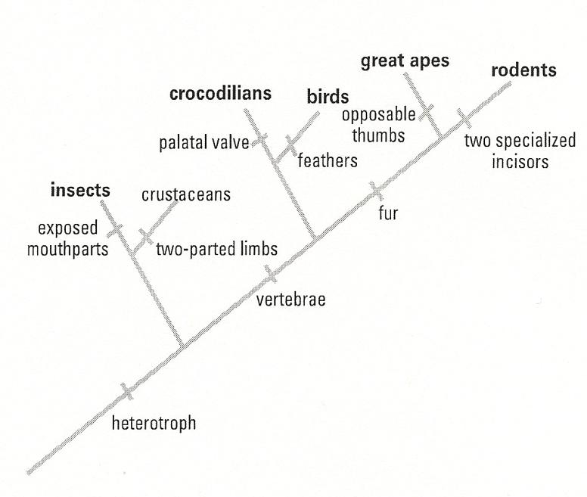

Figure 4: Cladogram of some related groups to the newly discovered fossil found near Liaoning Province, China.
PART I Questions:
- 1) Once you have loaded each of your sequences into BLAST, and you have your results, indicate which species in the results has the most similar gene sequence to each gene of interest.
Gene 1: __________________________________________________________________
Gene 3: __________________________________________________________________
Gene 4: __________________________________________________________________
2) How similar is the gene sequence (for each gene)?
Gene 1: __________________________________________________________________
Gene 3: __________________________________________________________________
Gene 4: __________________________________________________________________
3) Where is that species located on your cladogram? (Describe the nearby branches – for each gene.)
Gene 1: __________________________________________________________________
Gene 3: __________________________________________________________________
Gene 4: __________________________________________________________________
4) Did the analysis of each gene support or refute your original hypothesis? Did you have to redraw your original cladogram based on your results?
__________________________________________________________________________
__________________________________________________________________________
__________________________________________________________________________
PART II – Designing Your Own Investigation
Hypothesis:________________________________________________________________
__________________________________________________________________________
PART II Questions:
7) What is the function in humans of the protein produced from the gene you selected?
__________________________________________________________________________
__________________________________________________________________________
__________________________________________________________________________
8) Would you expect to find the same protein in other organisms? If so, which ones – why? Which other organisms had gene sequences most similar to the human gene you selected?
__________________________________________________________________________
__________________________________________________________________________
__________________________________________________________________________
9) Is it possible to find the same gene in two different kinds of organisms but not find the protein that is produced from that gene? Why might this happen?
__________________________________________________________________________
__________________________________________________________________________
__________________________________________________________________________
10) If you found the same gene in all organisms you test, what does this suggest about the evolution of this gene in the history of life on earth?
__________________________________________________________________________
__________________________________________________________________________
__________________________________________________________________________

