Name: ___________________________________________ Period:___________________

BLAST Lab: Using Bioinformatics to Investigate
Evolutionary Relationships
Introduction:
Between 1990-2003, scientists working on an international research project known as the Human Genome Project, were able to identify and map the 20,000 – 25,000 genes that define a human being. The project also successfully mapped the genomes of other species, including the fruit fly, mouse and Escherichia coli. The location and complete sequence of the genes in each of these species are available for anyone in the world to access via the Internet.
Why is this information important? Being able to identify the precise location and sequence of human genes will allow us to better understand genetic diseases. In addition, learning about the sequence of genes in other species helps us understand evolutionary relationships among organisms. Many of your genes are identical of similar to those found in other species.
Suppose you identify a single gene that is responsible for a particular disease in fruit flies. Is that same gene found in humans? Does it cause a similar disease? It would take you nearly 10 years to read through the entire human genome to try to locate the same sequence of bases as that in fruit flies. This definitely isn’t practical, so a sophisticated technological method is needed.
Bioinformatics is a field that combines statistics, mathematical modeling, and computer science to analyze biological data. Using bioinformatics methods, entire genomes can be quickly compared in order to detect genetic similarities and differences. An extremely powerful bioinformatics tool is BLAST, which stands for Basic Local Alignment Search Tool. Using BLAST, you can input a gene sequence of interest and search entire genomic libraries for identical or similar sequences in a matter of seconds.
In this investigation, you will use BLAST to compare several genes, and then use the information to construct a cladogram. A cladogram (also called a phylogenetic tree) is a visualization of the evolutionary relatedness of species. Figure 1 to the right is a simple cladogram.
Note that the cladogram is treelike, with the endpoints of each branch representing a specific species. The closer the two species are located to each other, the more recently they share a common ancestor.
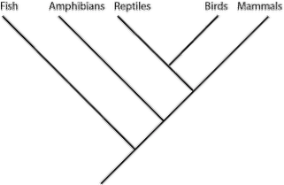

Figure 1: A simple cladogram of the Phylum Chordata.

The second cladogram in Figure 2 below includes additional details, such as the evolution on particular physical structures called synapomorphies (shared derived characters/traits). Note that the placement of the derived traits corresponds to when (in general, not a specific, sense) that character evolved; every species above the character label possesses that structure. For example, mice and chimps have hair but salamanders and perch do not.
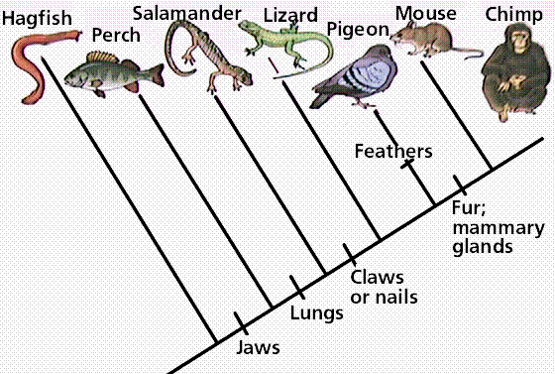

Figure 2: A simple cladogram showing synapomorphies - shared derived traits.
Historically, only physical structures were used to create cladograms; however modern-day cladistics relies heavily on genetic evidence as well. Chimpanzees and humans share over 95% of their DNA, which would place them closely together on a cladogram. Humans and fruit flies share approximately 60% of their DNA, which would place them farther apart on a cladogram.
Example 1:
Use the following data to construct a cladogram for the major plant groups below the table.
Table 1: Physical Characteristics of Major Plant Groups
Plant Group | Vascular Tissue | Flowers | Seeds
mosses | 0 | 0 | 0
pine trees | + | 0 | +
flowering plants | + | + | +
ferns | + | 0 | 0
Draw the cladogram for the groups here:

Example 2:
GAPDH (glyceraldehydes 3-phosphate dehydrogenase) is an enzyme that catalyzes the sixth step in glycolysis, an important reaction that produces molecules used in cellular respiration. The following data table shows the percentage similarity of this gene and the protein it expresses in humans versus other species. For example, according to the table, the GAPDH gene in chimpanzees is 99.6% identical to the gene found in humans, while the primary sequence of the corresponding protein is identical.
Table 2: Percentage Similarity of the GAPDH Gene and Protein with Homo Sapiens
Species | Gene Percentage Similarity with Homo Sapiens | Protein Percentage Similarity with Homo Sapiens
Chimpanzee (Pan troglodytes) | 99.6% | 100%
Dog (Canis lupis familiaris) | 91.3% | 95.2%
Fruit fly (Drosophila melanogaster) | 72.4% | 76.7%
Roundworm (Caenorhabditis elegans) | 68.2% | 74.3%
Questions:
1) Why is the percentage similarity in the gene always lower than the percentage similarity in the protein for each of the species? (Hint: Recall how a gene is expressed to produce a protein.)
__________________________________________________________________________
__________________________________________________________________________
__________________________________________________________________________
__________________________________________________________________________
2) Draw a cladogram depicting the evolutionary relationships among all five species (including Humans) according to their percentage similarity in the GAPDH gene.

3) The following four alien species were discovered, and it was realized that species “A” is very primitive – therefore it is the outgroup for the bunch. Use the pictures of each species to answer the following questions.
a. Fill out the following character matrix with a “O” for the ancestral trait (outgroup), and a “+” for a derived trait (different than outgroup).
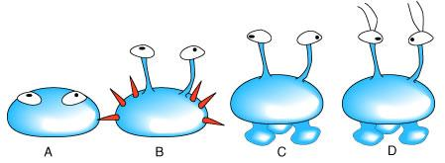

Physical Characteristic | SPECIES
 | A | B | C | D
Eyes present
Spines present
Eyes of stalks
“feet” present
Antennae present

b. Generate a cladogram from the above matrix in the space below. Label the position of the synapomorphies.

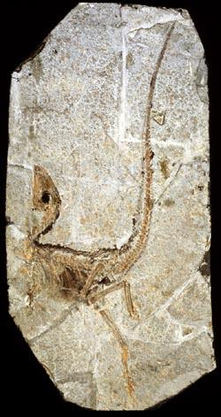
PART I – Using BLAST
A team of scientists has uncovered the fossil specimen in the photo to the right (Figure 3) near Liaoning Province, China. You should make some preliminary observations about this fossil based on its morphological features.
Little is known about the fossil. It appears to be a new species. Upon careful examination, small amounts of soft tissue have been discovered. Normally, soft tissue does not survive fossilization; however, rare situations of such preservation do occur. Scientists were able to extract DNA nucleotides from the tissue and use the information to sequence several genes.
You will use bioinformatic methods to support a hypothesis as to the evolutionary relationship between modern organisms and a fossilized organism using DNA collected from soft tissues. You will use BLAST to analyze the information from several genes and determine the most likely placement of the fossil species on the figure on the right.
Figure 3: Newly discovered chordate species found near Liaoning Province, China.
Procedure:
1. Form an initial hypothesis as to where you believe the fossil specimen should be place on the cladogram based on the morphological observations you made earlier. Draw your hypothesis on the cladogram to the right (Figure 4).
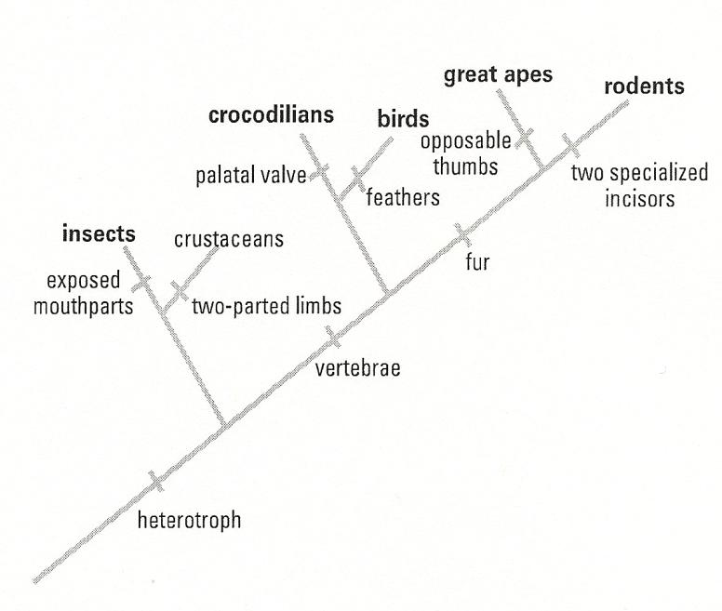

Figure 4: Cladogram of some related groups to the newly discovered fossil found near Liaoning Province, China.

- Locate and download gene files 1, 3, and 4 obtained by sequencing the DNA collected from the soft tissue in the fossil. Download 3 files from: http://blogging4biology.edublogs.org/2010/08/28/college-board-lab-files/. They can be downloaded from Mr. Walkers website as well. www.walkersclass.com
(When you download these files, rename them to “gene1”, “gene3”, and “gene4” to your account. You will not be able to view them but you will be able to upload them into the BLAST site.)
- Upload each gene sequence into BLAST by following the directions below. You will be doing this for each sequence separately.
  - Go to the BLAST site: http://blast.ncbi.nlm.nih.gov/Blast.cgi
  - Click on “Saved Strategies” from the menu at the top right side of the page. This will allow you to upload your first file.
  - Under “Upload Search Strategy,” click on “Browse” and locate your first file in your file directory. (gene1)
  - Click on “View.”
  - A screen will appear with the parameters for your query already configured. NOTE: Look but do not alter any of the parameters. Scroll down the page and click on the “BLAST” button at the bottom of the page.
  - Collect and analyze the information from your first gene sequence (according to the instructions on the next page). Then do this with the other gene sequences.
Analysis of Sequences – Descriptive Summary
Table 3 below lists from top to bottom the information about each of the organisms that were represented in the graphic summary. The species in the list are those with sequences identical to or most similar to the gene of interest. The most similar sequences are first, and as you move down the list, the sequences become less similar to your gene of interest.
NOTE: Species with common ancestry will share similar genes. The more similar genes two species have in common, the more recent their common ancestor and the closer the two species will be located on the cladogram.
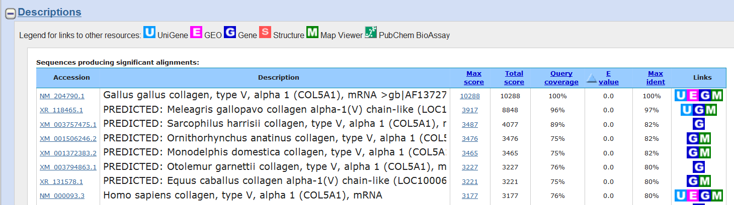
Table 3: Descriptive Summary from BLAST

Accession: If you click on the Accession number for a particular species listed, you will get a full report (Figure 6) that include the classification scheme of the species, the research journal in which the gene was first reported, and the sequence of bases that appear to align with your gene of interest. It will identify the gene, in this case it is collagen, that you are working with and you will also see the common name of the organism if it has one!

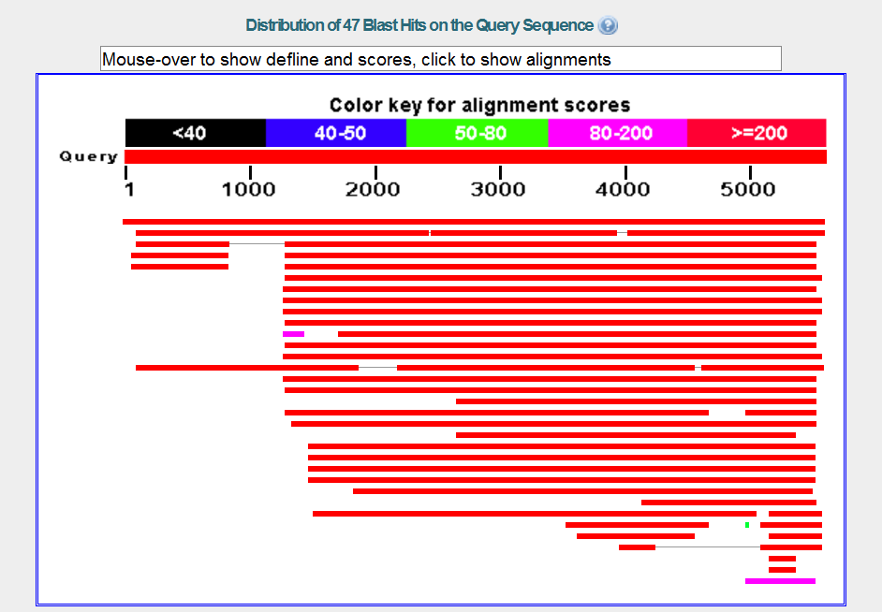
Analysis of Sequences – Graphic Summary
The chart below (Figure 5) is a graphical summary of your first sequence. The first line represents the most similar sequence that BLAST was able to pull from the data bases it searched. If you hover over the line, you will see the species of organism that this sequence was derived from. Other, less similar sequences are included from top (most similar) to bottom (less similar).

Figure 5: Graphical summary from BLAST.
4. Scroll back up to the top of the analysis page. Right above the graphics section, find “Other reports”. Click on “Distance tree of results” to see how this gene aligns with other species.
Alignments
Figure 7 shows the actual nucleotide comparisons between your unknown or “query” sequence and the most common sequence belonging to Gallus gallus. The results are tedious at best but there is a quick way for you to build a cladogram for the sequences. Click on “Distance tree of results” above the chart. You can click on the tabs above the tree and switch from rectangle, to slanted, to radial and force diagrams.
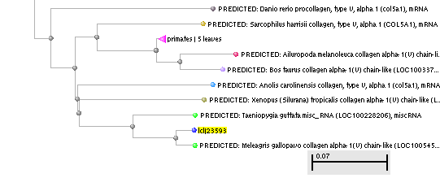
If you find that your tree seems a bit complicated, go back to BLAST, download the file a second time and go to “Optimize for” and select “Somewhat similar sequences.” The resulting tree will be less complex. If you want to save a picture of your tree, right click on the tree and save it as a .png You can then insert it into a document.

Figure 7: Cladogram generated from BLAST showing how the unknown sequence aligns with a chosen group of species.
PART I Questions:
- 1) Once you have loaded each of your sequences into BLAST, and you have your results, indicate which species in the results has the most similar gene sequence to each gene of interest.
Gene 1: __________________________________________________________________
Gene 3: __________________________________________________________________
Gene 4: __________________________________________________________________
2) How similar is the gene sequence (for each gene)?
Gene 1: __________________________________________________________________
Gene 3: __________________________________________________________________
Gene 4: __________________________________________________________________
3) Where is that species located on your cladogram? (Describe the nearby branches – for each gene.)
Gene 1: __________________________________________________________________
Gene 3: __________________________________________________________________
Gene 4: __________________________________________________________________
4) Did the analysis of each gene support or refute your original hypothesis? Did you have to redraw your original cladogram based on your results?
__________________________________________________________________________
__________________________________________________________________________
__________________________________________________________________________
__________________________________________________________________________
PART II – Designing Your Own Investigation
Now that you have completed this investigation, you should feel more comfortable using BLAST. The next step is to learn how to find and BLAST your own genes of interest. If you select a human gene, BLAST will compare that gene sequence to any similar sequences in the databases. You will be researching the closest match to your human gene.
Hypothesize as to the species of organisms that might have the most similar genes to humans.
Hypothesis:________________________________________________________________
__________________________________________________________________________
__________________________________________________________________________
- To locate a gene, you will go to the Entrez (IIPA: / t e/)
http://www.ncbi.nlm.nih.gov/sites/gquery and select “gene”.
- Search for a gene that you know is present in humans. For example, you might use human actin, myosin, catalase, keratin or ubiquitin – or another one that you can pick that we mentioned in lecture/extra credit/etc. You can use gene names like Pax1, SRY1. Enzymes are also proteins so you might search “human ATP synthase”. You can decide which gene you want to use. Type the name of the human gene in the search bar and click on “search.”
- In the previous assignment, you were given gene sequences to put into BLAST. In this assignment, you have used Entrez to find a segment you want to search for. The page you are on now, lists the results of your search. You should be able to select a reasonable sequence by clicking on the heading.
- This next page has a lot of information about your gene but scroll all the way down to, “NCBI Reference Sequences (RefSeq).” One of the things you can do is to select a gene sequence FASTA file but, try something new. Select a file under “mRNA and Proteins.” You can then select a sequence that codes for the mRNA. Click on one of the selections. In the next page, click on “FASTA”.
NOTE: FASTA format is a text-based format for representing either nucleotide sequences or peptide sequences, in which nucleotides or amino acids are represented using single-letter codes – ACGT for nucleotides; ACDEFGHIKLMNPQRSTVWY for amino acids.
- You will see a sequence of DNA nucleotides complimentary to the mRNA for the protein you have selected. Copy this sequence (only the nucleotides), and return to BLAST http://blast.ncbi.nlm.nih.gov/Blast.cgi
- Select “Nucleotide BLAST” and, instead of selecting “Saved strategies” just paste your sequences into the rectangle box labeled “Enter Query Sequences.” You will be pasting a FASTA sequence into the box.
- You can change some of the parameters of your analysis at this point. For example, under “Choose Search Set.” You can select whether you want to search the human genome only, the mouse genome only, or all genomes available. Under “Program Selection,” you can choose whether or not you want highly similar sequences or somewhat similar sequences. Choosing “Somewhat similar sequences” will provide you with more results but your tree will be much more complex.
- Click on BLAST and you will get the analysis of your gene of interest.
PART II Questions:
7) What is the function in humans of the protein produced from the gene you selected?
__________________________________________________________________________
__________________________________________________________________________
__________________________________________________________________________
8) Would you expect to find the same protein in other organisms? If so, which ones – why? Which other organisms had gene sequences most similar to the human gene you selected?
__________________________________________________________________________
__________________________________________________________________________
__________________________________________________________________________
9) Is it possible to find the same gene in two different kinds of organisms but not find the protein that is produced from that gene? Why might this happen?
__________________________________________________________________________
__________________________________________________________________________
__________________________________________________________________________
10) If you found the same gene in all organisms you test, what does this suggest about the evolution of this gene in the history of life on earth?
__________________________________________________________________________
__________________________________________________________________________
__________________________________________________________________________
__________________________________________________________________________

